**github link: https://github.com/amarbabughanta/week3**

**ERD Model PART 3**

Illustrate that you understand normalization and how to use it to reduce uncontrolled redundancy in your database design by creating two ERD diagrams:

**Answer:** Normalization has been used in this database system in order to decline the redundancy of data values. It has effectively applied to give structure to the different data values and eliminate the duplicate values whenever found in the dataset. Subsequently, a large dataset can be divided into smaller tables that sequentially helped an analyst to develop an ERD diagram.

Create the first using UML and the Umlet free utility.

**Answer:**

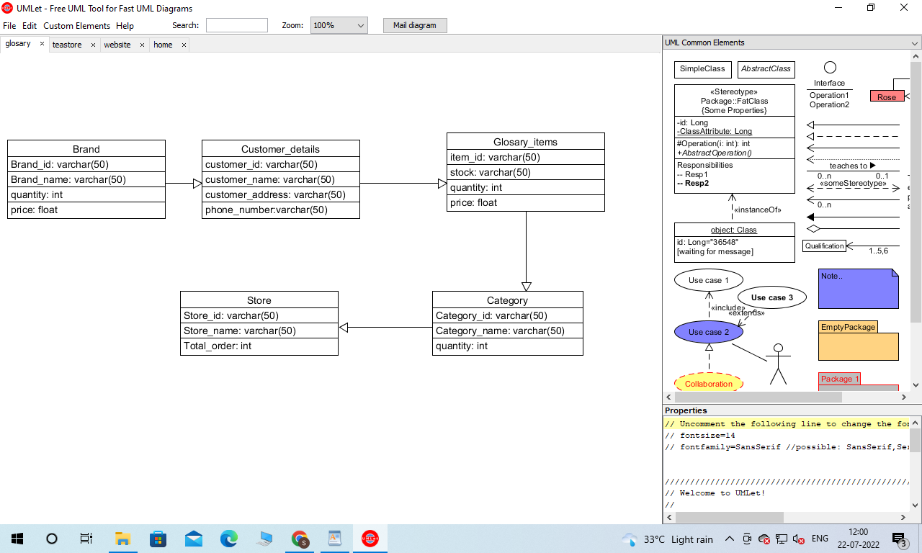

Create the second using Crow’s Foot notation in Vertabelo.

**Answer:**

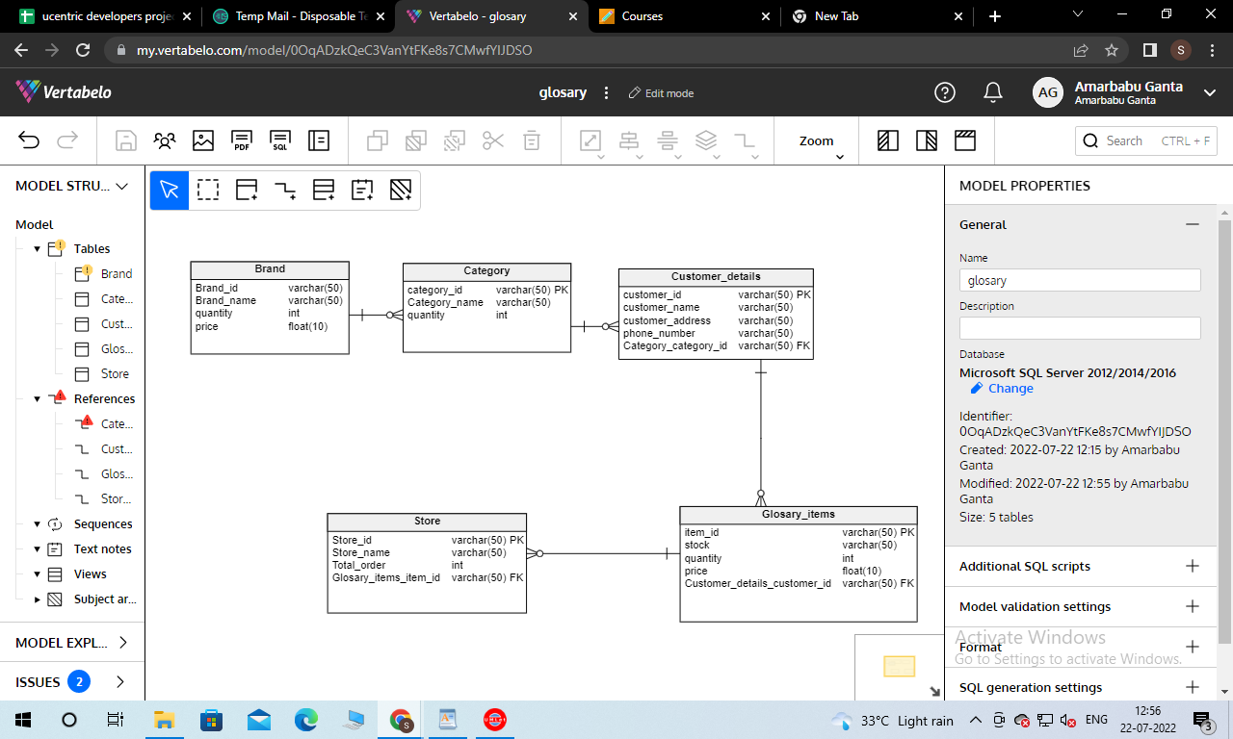

**Description of Entity Relationship Diagram:**

From the above figure, a type of Entity Relationship Diagram(ERD) is drawn for a Grocery store web application’s database system. Brand is single but its product exists in multiple forms and therefore, a one-to-many relationship has been applied between Brand and Product table. Similarly, a single product type can be consumed by many customers which sequentially emphasizes to incorporate a one-to-many relationship between Customer and Product table. Like the aforementioned relationship, the further series of tables with its respective prior table uses this one-to-many relationship concept which ends up at Store.